

*For More Visit* [*www.tekartlearning.com*](http://www.tekartlearning.com/)

*Tekart Learning*

**Name: School: Year:**

**©** [**www.tekartlearning.com**](https://www.tekartlearning.com/) **Page 1**

*For More Visit* [*www.tekartlearning.com*](http://www.tekartlearning.com/)

*For More Visit* [*www.tekartlearning.com*](http://www.tekartlearning.com/)

*Table of Contents*

PAPER 1 3

PAPER 2 12

PAPER 3 19

PAPER 4 28

PAPER 5 37

PAPER 6 47

PAPER 7 56

PAPER 8 66

PAPER 9 76

PAPER 10 85

PAPER 13 112

PAPER 14 120

For more Booklets of this kind, Visit [www.tekartlearning .com](http://www.tekartlearning.com/) or call +256754895241

|  |
| --- |
| **PAPER 1** |
| **SECTION A (40 marks)**   1. **Name one domestic animal kept for transport.** 2. **In which town council / division is your school?** 3. **Which physical feature is used for fishing?** 4. **State one cardinal point of a compass.** 5. **Which type of weather makes people slide?** 6. **Give one way farming is important to people.** 7. **Name one important place in a community where people go for security reasons.** 8. **Give one example of a basic resource in our environment.** 9. **Why is child abuse dangerous to children?** 10. **Give one danger of floods.** 11. **State one cause of insecurity in a home.** 12. **Give one way a school is useful to the community.** |
|  |

1. **In which season do farmers market (sell ) their crops?**
2. **How are parents important to their children?**
3. **Give the importance of a bell in a school.**
4. **Give one example of leaders who help to settle disputes in a community.**
5. **In which one way are doctors important to people?**
6. **State any one right of children.**
7. **How are traders important to the people in a community?**
8. **How do people use money to meet their needs?**
9. **What helps people to spend their money wisely?**
10. **Write UWEC in full.**
11. **At what time of the day is your shadow very short?**
12. **Name one material used to make clothes.**
13. **Mention one group of people who use a compass in their work.**
14. **Which element of weather helps people to harvest water?**
15. **Give one way in which hills are useful to the people in the community.**
16. **How do swamps help people when building houses?**
17. **Which clouds are helpful to farmers?**
18. **Give one way you can help the needy.**
19. **Write the commonest economic activity done by people in villages.**
20. **Give one importance of keeping goats.**
21. **Name one tribe of people in your sub – county.**
22. **Name the leader who led the Israelites out of Egypt.**
23. **Where did Adam and Eve live?**
24. **State one gift of the Holy Spirit.**



1. **Give one way of worshiping God.**
2. **Why do we repent our sins?**
3. **Why do Christians pray to God?**
4. **Who baptized Jesus?**

SECTION B

1. **Study the diagram below and answer the questions that follow:**

OTEMA’S HOUSE

R

Q

* 1. **Name the physical features marked Q and R.**
     1. **Q**
     2. **R**
  2. **State any one problem that will affect Otema and his house.**
  3. **How is physical feature R useful to people?**

42 a) Why do school pupils put on uniforms?

1. **Name any one symbol of a school found on your uniform.**



1. **How can you take care of your uniforms?**
2. **(a) Write the materials used for making these items.**
   1. **Pots**
   2. **Mats**
   3. **Ropes**

(b) How are mats useful at home?

1. **(a) is the movement of people and goods from one place to another.**
2. **State any two problems faced by people who move on roads**

(i)

(ii)

1. **How is this traffic road sign useful to pedestrians?**
2. **(a) Give two uses of domestic animals. (i)**

(ii)

1. **State two ways of caring for domestic animals. (i)**

(ii)

1. **(a) Write L.C in full.**

(b) Give two qualities of a good LC 1 leader. (i)

(ii)

1. **How is the work of the LC similar to that of the police?**
2. **(a) Who is a child?**

(b) Mention two rights a P.3 child. (i)

(ii)

(c ) How do some people abuse children’s right?

48. (a) What is weather?

1. **Name any two types of weather. (i)**

(ii)

( c) Draw and name one item used in managing rainy weather.

1. **(a) Mention any two things needed to start a project. (i)**

(ii)

1. **Why do people set up projects?**
2. **How can people keep their money safely?**
3. **(a) How are these people important in a home?**
   1. **Parents**
   2. **Maids**
4. **Name one type of family.**
5. **Why should a family have a house?**

RELIGIOUS EDUCATION

1. **(a) Which custom makes us members of God’s family?**

(b) Name one member of God’s family.

(c ) How do we show love to others?

(d) Draw and name one symbol of a Christian family.

1. **(a) Why was Judas a bad apostle?**
2. **Name one other apostle of Jesus.**
3. **How did Jesus show love to the world?**
4. **Mention any one miracle performed by Jesus.**
5. **(a) What is a prayer?**

(b) Give two reasons why we pray to God. (i)

(ii)

1. **On which day do Christians go for general prayers?**
2. **Match the following correctly. A B**

Cross blood of Jesus

Bread the Holy Spirit

Wine sign of God’s love

Dove body of Jesus

1. **Cross**
2. **Bread**
3. **Wine**
4. **Dove**
5. **(a) Why did God create these objects?**
   1. **The sun**
   2. **plants**

(b) Name the first two people God created.



|  |
| --- |
| **PAPER 2** |
| **SECTION ‘A’ – 40 marks**   1. Name any **one** classroom object. 2. Write down the name of your school. 3. Give any **one** means of communication. 4. How can we keep our school compound clean? 5. Draw a picture of a table in the space below. 6. Write any **one** important place in our division. 7. Name any **one** cardinal point of a compass. 8. Give any **one** use of water at home. 9. Why do animals move from one place to another? 10. Name the map symbol below.      1. Name any **one** language spoken in our division. |

1. Write Hosp. in full
2. Give **one** role of a teacher in our division.
3. Name any **one** example of a food crop.
4. Give any **one** example of a domestic bird.
5. Which animal provides us with mutton?
6. Of what importance is the sun to man?
7. Mention the place where we can keep our money safely.
8. Why is a library important in a school?
9. Name the type of clouds which give us rain.
10. Which local material can we use to make a rope?
11. Name any **one** modern means of communication.
12. In which direction does the compass needle rest?
13. How are doctors important in our community?
14. Mention any **one** type of transport in our division.
15. Mention any **one** mineral got from lake Katwe.
16. Name the central bank in Uganda.
17. A person who flies an aeroplane is called

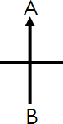

1. Why do school children put on a uniform?
2. Give **one** example of wild animals.
3. In which season do farmers harvest their crops?
4. What do we call the keeping of the environment clean?
5. Mention the bad brother of Nambi.
6. Give any **one** example of furniture.
7. Name any **one** place you can take sick children for treatment.
8. Give **one** example of a material used to build temporary houses.
9. What name is given to a drawing of an object as seen from above?
10. Mention any **one** example of a physical feature.
11. Give any **one** element of a good map.
12. Mention any **one** important place in your division.

SECTION B

1. Study the diagram below and answer the questions that follow/
   1. Name the cardinal points marked;

A :

B :

1. In which direction does the sun rise from?
2. Give **one** group of people who use a compass.
3. Name any **two** animals kept for sale.

6. Give any **two** products from animals.
7. Draw these things made out of wood.

|  |  |  |  |
| --- | --- | --- | --- |
| **Chair** | **Cupboard** | **Table** | **Bed** |
|  |  |  |  |

1. Give **two** types of weather.

4. Give **two** uses of wind.
5. Mention any **two** members of a nuclear family.

8. Write **two** basic needs of man.
   1. (ii)
9. What do we call the movement of people with their goods from one place to another?
10. Mention **two**means of transport.
11. Where do pedestrians cross the busy roads from?
12. Draw these map symbols.

|  |  |  |
| --- | --- | --- |
| **Mountain** | **River** | **Swamp** |
|  |  |  |

b) How important are rivers to people?

1. Match correctly.

List ‘A’ List ‘B’

policeman bus park

Doctor hospital

Teacher police post

Driver school

1. What is a compass?
2. Give **three** examples of cardinal points.
3. What is transport?
4. Mention any**two** types of transport.

(i) (ii)

1. Why is an aeroplane better than a taxi?
2. Mention any **two** symbols of a school.

(i) (ii)

1. Give **two**important people found at your school.
   1. (ii)
2. Write LC in full.
3. Mention any **two** members on the L.C.I Committee.
4. What are domestic animals?
5. Name any **two** domestic animals.
   1. (ii)
6. How is a donkey useful at home?
7. What are physical features?
   1. Mention any **two** physical features.
   2. Why is it bad to live near lakes and rivers?
8. Mention **two** common accidents at home. (i)

(ii)

* 1. Write down **two** items found in the first aid box.

|  |
| --- |
| **PAPER 3** |
| 1. **Name one symbol of a school.** 2. **Which animal is used for transport?** 3. **In which one way are banks important to people in a community?** 4. **Write one material got from swamps.** 5. **Which lake is found in Kampala district?** 6. **State one duty of a father in a home.** 7. **Write UPE in full.** 8. **Give one example of Natural landforms.** 9. **Write one basic resource in our environment.** 10. **Give one example of a recreational centre.** 11. **Which type of weather is managed by using the item below?** |
|  |

1. **Write one danger of domestic animals.**

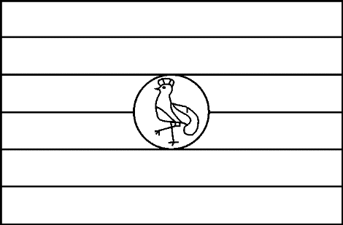

1. **How are local council leaders important in a community?**
2. **Give one way of spending money wisely.**
3. **Name one place in a community where people go for treatment.**
4. **Name any one source of water.**
5. **Name the commonest type of transport in our sub county.**
6. **Which colour is marked with letter K on the Uganda flag below?**

K

1. **What is a picture?**
2. **Which animal is kept at home for security.**
3. **In which one way is a school important to a community?**
4. **How are children abused in Uganda?**
5. **Give one example of “cultural practice in a community.”**
6. **How are teachers important in our sub county?**
7. **What is a family?**
8. **Which school symbol is found on your uniform?**
9. **Give one importance of school projects.**
10. **Which people help children to cross a busy road?**
11. **How does the police keep law and order?**
12. **What are the cardinal points of a compass?**
13. **Give one danger of earth quakes.**
14. **Why do we need class rules?**
15. **Draw a traffic road sign for ‘No parking’.**
16. **Which physical feature is used for fishing?**
17. **Give one reason why we should take care of trees in our compound.**

For questions 36 – 40, answer Christianity.

1. **Why do Christians go to church?**
2. **Give one way you can help needy people.**
3. **Name one gift of the Holy Spirit.**
4. **What is Lent?**
5. **Draw and name one Christian symbol.**

SECTION B

1. **(a) What are cash crops?**
   1. **State the product got from these crops.**
      1. **cotton**

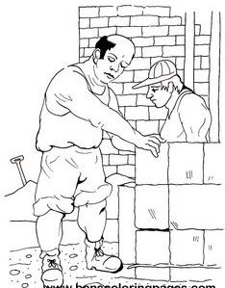

* + 1. **sugar canes**
  1. **How can we care for the crops in our school garden?**

1. **Study the diagram below and answer the questions about it.**
   1. **Which type of house is being built above?**
   2. **Name two materials used to build the above house?**
      1. **(ii)**
   3. **How is a house useful to people?**
2. **(a) Who is a child?**
3. **Mention any two needs of a child.**
   1. **(ii)**
4. **Which Local Council leader is responsible for children’s affairs?**

|  |  |
| --- | --- |
| 1. **(a) Which social services are provided by these people?**    1. **Bankers**    2. **Teachers**    3. **Doctors and nurses**   **(b) State one problem faced in providing social services.**   1. **(a) Name these basic resources.**    1. **A (ii) B**   **(b) How is resource ‘A’ useful to people?** | |
| **(c) Why do we save resources?**  **46. (a) What are wild animals?** | |
| **(b)**  **(c)** | **Name any one wild animal.** |
| **How are wild animals dangerous to people?** |

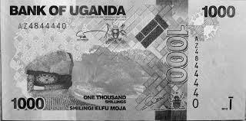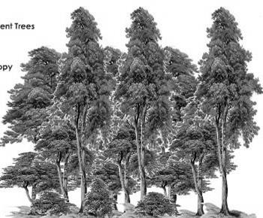



1. **Match the following correctly. A B**

Trade - making things out of wood.

Carpentry - buying and selling of goods.

Farming - making things out of clay.

Pottery - growing of crops and keeping animals.

Trade - Carpentry - Farming - Pottery

1. **(a) Mention one type of family.**
2. **What do you call the mother of your mother?**
3. **Draw and name two basic needs of a family.**

|  |  |
| --- | --- |
|  |  |
|  |  |

1. **(a) What do we call the movement of people and goods from one**

|  |  |
| --- | --- |
| **place to another?**   1. **Name any one means of water transport.** 2. **Why do people move from one place to another?** 3. **State any one problem people face while moving.**   **RELIGIOUS EDUCATION**  **50. (a) What is a prayer?** | |
| **(b)**  **(c)**  **51. (a)**  **(b)**  **(c)** | **Which prayer did Jesus teach his apostles?** |
| **State any two reasons why people pray to God.**    2. **Name the first two people to be created by God.**   **(i) (ii) How did these people disobey God?** |
| **Which creature tempted the above people to disobey God?** |
| 1. **(a) State two qualities of a good leader.**   **(b) Name any one leader in the Bible?** | |

|  |  |
| --- | --- |
|  |  |
| **(c) Give one duty of religious leaders.** | |
| **53. (a)** | **Who was the mother of Jesus?** |
| 1. **State any two miracles Jesus performed.** 2. **Mention any one apostle of Jesus.** | |
| 1. **(a) Match the following prophets with what they are remembered for.**   **A B**  **Moses - was swallowed by a big fish.**  **Jonah - Baptised Jesus.**  **Elijah - got the Ten Commandments. John the Baptist - Went to heaven alive.**   * 1. **Moses**   2. **Jonah**   3. **Elijah**   4. **John the Baptist** | |

|  |
| --- |
| **PAPER 4** |
| **SECTION ‘A’ (40 Marks)**   1. Name the domestic animal that gives us milk. 2. Name any **one** dinning SOP. 3. Write down any **one** activity that can be done by children at home. 4. Who heads a family? 5. Give the meaning of the word ***“social services”*** 6. State any **one** element of a good map. 7. In the space below, draw a picture of a cup.      1. Mention any **one** member of an extended family. 2. In which district is your school found? 3. Name any **one** symbol of a school. 4. How is a teacher important in a community? |

1. Mention any **one** Television station you know.
2. Identify the importance of a church in a community.
3. Give any **one** place where we can get water.
4. What item can you use to protect yourself from rainy weather?
5. Draw a map of a car in the space below.
6. How is a cow’s meat called?
7. Give any **one** material used in building a permanent house.
8. Write down any **one** example of a basic need.
9. How is a carpenter useful in the community?
10. Name the longest River in Uganda.
11. State any **one** tribe in your division.
12. Name any **one** tribe in your sub-county.
13. Give any **one** reason why some children do not go to school.
14. Name the person who keeps security at school.
15. What are economic activities?
16. Give **one** example of building materials.

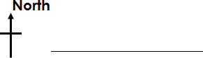

1. State the main use of donkeys.
2. Name the map symbol below;
3. Who heads a sub-county?
4. Why do school children wear uniforms**?**
5. Name any **one** game which is played in water.
6. Name the play material below.
7. In which season do farmers harvest their crops?
8. Mention any **one** gift you can give on your friend’s birthday.
9. Who heads the Local Council Committee**?**
10. Name any **one** element of weather.
11. Name the road sign below.

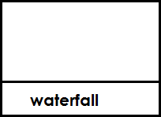

1. State any **one** use of hills in your sub-county.
2. Mention any **one** example of a physical feature.

SECTION ‘B’ (60 Marks)

1. a) What is a map?
2. Outline any **two** elements of a good map.
3. Draw a map symbol below.
4. a) What are physical features?
5. Mention any **one** example of a mountain you know.

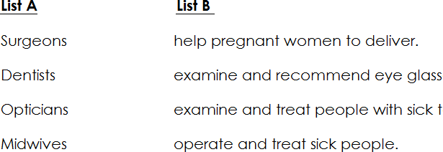

1. Mention any **two** uses of lakes to people. (i)

(ii)

1. Mention the groups of doctors in **List A** with their work in **List B**.
   1. Surgeons;
   2. Dentists;
   3. Opticians;
   4. Midwives;
2. a) Mention the local language spoken by people in your community.
3. Name **three** ethnic groups in your division.
4. a) Mention any **two** qualities of a good leader.

7. Mention any **one** example of a religious leader.
8. How are leaders important in communities?
9. a) What are cash crops?
   1. Give **two** examples of cash crops.
11. 1. Name any one crop grown in swamps.
12. What is transport?
13. What title is given to a person who drives the school bus?
14. Apart from school bus, mention any other **two** means of road transport.
15. a) Mention any **two** play materials you know.

b) How are swings important to school children?

|  |  |  |  |
| --- | --- | --- | --- |
| c) Name any **one** game you play at school.   1. a) What are wild animals?    1. Mention **two** uses of animals to people.    2. Give any **one** example of a domestic animal. 2. a) What is fishing?    1. Mention any **two** types of fish caught in Lake Victoria.    2. Suggest any **one** way of preserving fish. | | | |
| 51. Fill the table below correctly. | | | |
|  | **Service** | **Place** | **People who provide th service.** |
| banking |  | bankers |
| security | Police Stations |  |
|  | school | teachers |
| medical |  | nurses and doctors |
|  | | | |

1. What is a community?

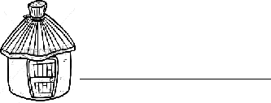

* + 1. Mention any **two** important places in a community.
    2. Where do we go for treatment?

1. a) Name the type of house drawn below.
2. Why do most people in villages build the above type of houses?
3. Write down **two** materials used to build a permanent house.
4. a) What is the main natural source of water?
5. Mention any **two** uses of water at home.
6. Write any **one** material used to harvest water.
7. The bar graph below shows occupations of people in Masese village.



**500**

**400**

**300**

**200**

**100**

**0**

**Farming Carpentry Trading Fishing Brick making**

1. Which occupation is done by many people in Masese village**?**
2. Name the occupation done by very few people in Masese.
3. Write the occupation which provides building materials.
4. How many people carry out fishing**?**

|  |
| --- |
| **PAPER 5** |
| **SECTION A : 40 MARKS**   1. **Name one element of a good map.** 2. **State one safe way of using roads.** 3. **How are doctors useful in a community?** 4. **State one activity done at school.** 5. **How can you help your parents at home?** 6. **Write one important place in our community.** 7. **What does this road sign show?** 8. **Give one danger of wild animals.** 9. **How can a P.3 pupil use her / his holiday well?** 10. **Who heads the local council committee?** 11. **What is child abuse?** |
|  |

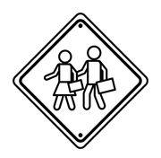

1. **State one dangerous thing found on the road.**
2. **State one way of keeping peace and security at school.**
3. **Name one basic resource in our environment.**
4. **Draw and name one material used to build a permanent house.**
5. **Why do people work?**
6. **How is a bank useful in a community?**
7. **State one way you should show respect to your teachers.**
8. **Which tribe speaks Lusoga?**
9. **How do people get their needs?**
10. **How can a P.3 child tell direction without using a compass?**
11. **Give one problem faced by the government in providing social services.**
12. **Why do animals move from one place to another?**
13. **Write one animal used for transport.**
14. **Why is it dangerous to settle in a valley?**
15. **A part from the school sign post, write any other thing which helps us to locate our school.**
16. **State one use of trees in our school compound.**
17. **How is the community useful to your school?**
18. **Name one cultural practice.**
19. **Give one importance of the sun.**
20. **Peter got shs. 20,000. What important thing should he do first before spending the money?**
21. **Give two uses of water.**
22. **Name one recreation activity at home.**
23. **How can you keep your classroom clean?**
24. **Write one gender role of girls and boys.**
25. **Name the holy book for Christians.**
26. **What should you do to people who do bad to you?**
27. **Why do people go to church?**
28. **State one miracle performed by Jesus.**
29. **Circle the custom which makes us members of God’s family.**

Worshipping, dressing, baptism, fasting.

SECTION B

1. **(a) Which type of clouds provide rain?**
2. **State any activities that Kisembo the farmer does in these seasons.**
3. **Dry**

season

1. **Wet season**
2. **How is too much rainfall dangerous to people?**
3. Below is a map of Bute village.

Key

* **church**
* **hill**
  + **forest**

-round about

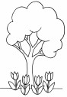

- river

**N - homes**

- road

**Bagezi Primary school**

- bridge

* + 1. **What does this symbol stand for?**
    2. **Name one type of transport used in his village.**
    3. **What is the direction of the hill from the school?**
    4. **How is Bagezi Primary School useful to the people?**

1. **(a) What do you call the son of your father?**

(b) Name two basic needs of a family.

(i) (ii)

(c ) How is a mother useful in a family?

1. **(a) Who is a child?**
2. **Give two rights of children.**

5. **Where can a child report when he / she is mistreated?**
6. **Complete the table below correctly.**

|  |  |  |  |  |  |  |
| --- | --- | --- | --- | --- | --- | --- |
|  | **Name** | | **Picture** | | **Use** | |
| **Hat** | |  |  | **for wearing** | |
|  |
| **Pot** | |  | |  |  |
|  |
| **Basket** | |  |  | **for carrying things** | |
|  |
|  |  |  | | **For skipping** | |
|  |  |

1. **(a) What are domestic animals?**
2. **Name two domestic animals kept for milk.**

(i) (ii)

1. **How can a P.3 child care for domestic animals?**
2. **(a) How are these physical feature useful to people?**
   1. **Lakes**
   2. **Hills**
3. **State one way of caring for hills.**
4. **Why is it not safe to stay in valleys?**
5. **Below is a graph showing some of the projects in Kisembo**

sub – county.

100

Number of people

80

60

40

20

0 Poultry keeping

cattle keeping

brick making

crop growing

1. **Which project is done by most people?**



1. **How many people do poultry keeping?**
2. **Name any one thing needed to start a project.**
3. **Which project on the graph destroys soil?**
4. **(a) What is transport?**
5. **Write one dangerous thing found on roads.**
6. **State one unsafe way of using roads.**
7. **How are police officers useful on roads?**
8. **Match the word in A to their meanings in B A B**

Marriage - babies born to one mother at the same time. Twins - union of husband and wife.

Clan - food commonly eaten in an area. Staple food - people under one fore father.

1. **Marriage**
2. **Twins**
3. **Clan**
4. **Staple food RELIGIOUS EDUCATION**
5. **(a) How many days did God take to create the universe?**

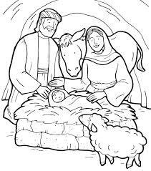

* 1. **How can we take care of these creations?**

1. **Plants**
2. **Animals** 
   1. **Name one source of light God created.**
3. (a) **Who cheated Esau’s blessing?**
4. **Why is cheating bad?**
5. **What should you do after sinning?**
6. **A part from cheating, name one other bad behaviour.**
7. **Study the picture and answer questions that follow.**
8. **Which person in the Bible was born in such a place?**
9. **On which day do Christians celebrate this birthday?**
10. **Name the mother of the baby in the manger.**
11. **How do Christians prepare for the birth of Jesus Christ?**
12. **(a) Give two ways of worshipping God. (i)**

(ii)

1. **Name any one place of worship.**
2. **Who tempted Jesus to bow down and worship him?**
3. **(a) State two qualities of a good leader. (i)**

(ii)

(b) Name one leader found in each of these places below,

1. **in a church**
2. **in a school**

|  |
| --- |
| **PAPER 6** |
| **SECTION A : 40 MARKS**   1. Name **one** element of a good map. 2. Why do school children wear uniforms**?** 3. How do you keep your classroom clean**?** 4. In which sub county is your school located**?** 5. Who heads the Local Council Committee**?** 6. How is a father useful in a home**?** 7. State **one** way of caring for plants in our compound. 8. Draw a map of a car in the space below. |

1. Mention **one** type of holiday.
2. How is a picture similar to a map**?**
3. What is a family**?**
4. Give **one** way your school is important to the community around.
5. Which type of transport is not used by people in your sub county**?**
6. Why is speeding of vehicles dangerous**?**
7. How are hospitals useful to us**?**
8. Give **one** reason why farmers plant their crops in a wet season.
9. State any **one** use of water at home**?**
10. Draw and name one item made from banana fibres.
11. Mention **one** group of people who keep peace and security.
12. Give any **one** problem you can face on your way to school.
13. What is a plateau**?**
14. How are children abused in homes**?**
15. State the direction of the sun in the evening hours**?**
16. How can you as a child keep security at home**?**
17. Why is it not good to settle in a valley**?**
18. Give **one** example of a cardinal point.
19. Why do we need humps on roads**?**
20. In which way are nimbus clouds useful to us**?**
21. Why do we fence our schools**?**
22. Name **one** domestic bird.
23. How are holidays useful to a P.3 pupil**?**
24. Give **one** importance of hills to people.
25. Which material do carpenters use to make furniture**?**
26. How do children help their parents at home**?**
27. Mention any **one** important place in our sub county.

For questions 36 – 40, answer Christianity.

1. How can you show love to other people**?**
2. Why do Christians pray to God**?**
3. What do we call the fasting period for Christians**?**
4. Who was the heavenly father of Jesus**?**
5. Mention **one** lesson you learn from Jesus.

SECTION B

1. (a) Write the motto of your school.
2. Write **two** symbols of a school.
3. Why should a school be with symbols**?**
4. (a) Which conditions of weather are shown below**?**

|  |  |  |
| --- | --- | --- |
|  |  |  |
|  |  |  |

(b) Which condition of weather helps to dry our clothes**?**

1. (a) Who is a leader**?**
2. State **two** qualities of a good leader.
3. Give **one** example of leaders in our sub county.
4. (a) What is another word to mean physical features**?**
5. List any **three** physical features found in your area.
6. (a) Write down the name of the following important people in your

school.

* 1. Headmaster -
  2. Class teacher -

1. What is the role of the following people at school**?**
   1. School nurse -
   2. teacher -
2. Which things can we make from the materials below**?**
3. sisal
4. clay
5. palm leaves
6. sticks
7. (a) Which group of people provide these social services**?**
   1. Education service
   2. Medical service
   3. Transport service

(b) State **one** problem the government faces in providing social services.

1. (a) What are domestic animals**?**
2. Name any **two** domestic animals**?**
3. How can you care for domestic animals**?**
4. **Occupations of people in Kira village.**

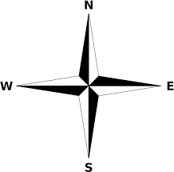

**500**

**400**

**300**

**200**

**100**

**0**

**Farming Carpentry Trading Fishing Brick making**

1. Which occupation is done by many people in Kira village**?**
2. Name the occupation done by very few people in Kira.
3. Write the occupation which provides building materials.
4. How many people carry out fishing**?**
5. (a) Name the instrument shown below.

.

|  |  |
| --- | --- |
| 1. How is the above instrument useful**?** 2. Give any **two** groups of people who use it in their work.   **RELIGIOUS EDUCATION**  **105.** (a) Who created the universe**?** | |
| (d)  (e) | Name any **two** things that were created. |
| How can we thank our creator**?** |
| 1. (a) In which river did John baptize Jesus**?**    1. Why should Christians be baptized**?**    2. Mention any **two** Christian customs. 2. (a) What do these things represent during the last supper**?** 3. wine 4. bread 5. Mention any **two** apostles who ate the last supper with Jesus. | |

|  |  |
| --- | --- |
| 1. **(a) Match the following people with what they are remembered for. A B**   Noah died for our sins.  Moses Father of all nations.  Abraham built the ark.  Jesus received the Ten Commandments.   * 1. Noah   2. Moses   3. Abraham   4. Jesus  1. (a) Identify any **two** gifts on your body that God gave you.    **(d)** How can we care for our body**?** | |
| **(e)** | Which part of the body do we use to worship God**?** |
|  |

|  |
| --- |
| **PAPER 7** |
| **SECTION A**   1. **Name any one type of leader.** 2. **Give one example of a school symbol.** 3. **Which animal is kept at home for security?** 4. **Along which road is your school located?** 5. **How are forests important to carpenters?** 6. **State one cultural practice is our community.** 7. **How are banks important in a community?** 8. **In which one way are hills important to people?** 9. **Name one social service in a community.** 10. **Draw a map of symbol for a plateau.** |

1. **How do we keep our classroom clean?**
2. **Give one way children help to keep peace and security at home.**
3. **How many members make up the Local Council I?**
4. **Why do we need health centres in our community?**
5. **What does this map symbol below show?**
6. **What name is given to a family where parents live with their children?**
7. **Give one example of a play material.**
8. **Apart from school children, which other people put on uniforms?**
9. **Why do we need trees in our school compound?**
10. **Write any one class rule.**
11. **How do people get their needs?**
12. **How is a father useful in a family?**
13. **Write one type of holidays.**
14. **Give one example of building materials for a hut.**
15. **In which one way is a school important to the community around.**
16. **Give one way of managing rainy weather.**
17. **State any one way of telling direction without using a compass.**
18. **Name the food got from rivers.**
19. **In which sub – county is your school found?**
20. **Which problem is faced by people who live in valleys?**
21. **State one activity done by pupils at school to keep the environment clean.**
22. **Give any one important place in our community.**
23. **Why do we need barbers in our sub – county?**
24. **In which direction does the sun set?**
25. **State one custom in our society.**

CHRISTIAN RELIGIOUS EDUCATION

1. **What name is given to the period when Christians fast?**
2. **How can one become a member of God’s family?**
3. **Give one way we can care for the needy people.**
4. **State the holy book for Christians.**
5. **Mention one Christian practice in our community.**

SECTION B: (60 marks) N

b a

c

* 1. **Name the cardinal points marked a, b and c.**

a b

c

* 1. **Which group of people need a compass in their work?**

1. **a) In which season do farmers harvest their crops?**
2. **Why do they harvest their crops in the season named above?**
3. **Give any two elements of weather.**

i) ii)

1. **a) Name two means of road transport.**

b) Which type of transport is used by few people?

1. **Name one dangerous thing found on the road.**
2. **Match the following correctly.**



Canal

hill

rift valley

bridge

1. **Fill the table below correctly.**

|  |  |  |
| --- | --- | --- |
| **Service** | **Place** | **People who provide the service.** |
| **Banking** | **(i)** | **Bankers** |
| **security** | **Police Stations** | **(ii)** |
| **(iii)** | **school** | **teachers** |
| **medical** | **(iv)** | **Nurses and doctors** |

1. **a) Which land forms are used for the following.**

(i) Fishing (ii)Stone mining

1. **State any two occupations done by people on a plateau.**

4. **a) Give three examples of basic needs of people.**

b) Give one reason why some homes lack basic needs.

1. **(a) Fill in the table below.**

|  |  |
| --- | --- |
| **Elements of weather** | **Types of weather** |
| **Sun** |  |
| **Clouds** |  |
| **Rain** |  |

b) In which season do farmers harvest their crops?

1. **a) State any two rooms found in a house.**
3. **b) Give one way a house is important to people.**

(c) Name one material used to build a house.

1. 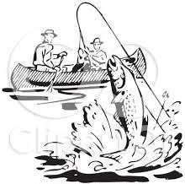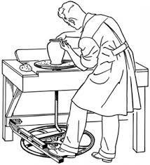**The pictures below show some of the economic activities carried in our sub – county.**

|  |  |  |  |
| --- | --- | --- | --- |
| **M** | **N** | | **Q**  Description: Related image |
| **R** | | **S** | |

* 1. 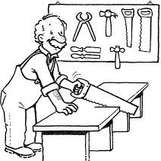**Name the activities carried out in;**

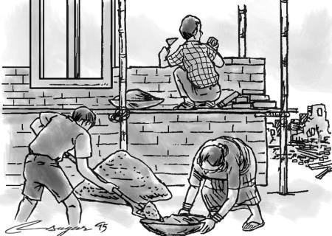

1. **M**
2. **N** 
   1. **Why do people carry out activity Q?**
   2. **Mention one product made by the person in picture R.**

RELIGIOUS EDUCATION

1. **a) Name the first two people to be created by God.**

4. **How did the above people disobey God?**
5. **In which garden did the above people live?**
6. **a) Why did Jesus die on the cross?**
7. **On which day do we remember the death of Jesus?**
8. **State one miracle performed by Jesus.**
9. **Name one apostle of Jesus.**
10. **a) Why do Christians pray?**
11. **Who leads prayers in a church?**
12. **State one quality of a good church leader.**
13. **Draw and name one item found in a church.**
14. **a) State one way we can care for the needy.**
15. **Name any two gifts that God gave you on your body.**

18. **How can a P.3 pupil care for his / her body?**
19. **Match the following people with what they are remembered for. John the Baptist went to heaven alive**

Noah got the commandments

Elijah baptised Jesus

Moses built the Ark

* 1. **John the Baptist**
  2. **Noah**
  3. **Elijah**
  4. **Moses**

|  |
| --- |
| **PAPER 8** |
| **SECTION A : 40 MARKS**   1. **In which Sub County or Division is your school located?** 2. **Give one role of a mother at home.** 3. **How can you tell the direction of places without using a compass?** 4. **Name any one kind of roads in our Sub County /Division.** 5. **Identify any one play item that can be made from banana fibres.** 6. **Name the type of transport where donkeys can be used.** 7. **Mention one thing people can use to locate our school.** 8. **Why do we keep our money in banks?** 9. **Name any one dangerous thing that can be found on the road.** 10. **How can a P.3 child care for crops in the school garden?** 11. **Mention one important place in our Sub County / Division.** |

1. **Draw and name any one tool used in communication.**
2. **Give any one importance of swamps to people in our Sub County.**
3. **State one importance of recreation centres.**
4. **How can a P.3 child make good use of his/her holidays?**
5. **Name any one colour in the Uganda flag.**
6. **Why do we grow cash crops in Sub County / Division?**
7. **Give one way of controlling child abuse.**
8. **How useful is a nurse at school?**
9. **State any one effect of insecurity in our Sub County / Division.**
10. **How can you show respect to elders?**
11. **Who heads the Local Council I Committee?**
12. **Give one importance of the things (such as mats, baskets, pots etc) that we make at school.**
13. **Why do tribes put on traditional wear?**
14. **How does a school benefit from the community around?**
15. **Where can people go for medical services?**
16. **How is a map similar to a picture?**
17. **State one use of rivers to people.**
18. **How can you manage cold weather?**
19. **Name one custom in our sub county.**
20. **What is child abuse?**
21. **Give any one tool used for catching fish.**
22. **Mention one taboo in your area.**
23. **Name the map symbol below.**
24. **How important can a radio station be in the community?**

For questions 36 – 40, answer Christianity.

1. **How can we help needy people?**
2. **State one duty of a priest in a church.**
3. **What do we call the fasting period for Christians?**
4. **Why do Christians go to church?**
5. **As a Christian, what do you do when your friend does something bad**

to you?

SECTION B

1. **(a) What is a map?**
2. **Mention any two elements of a good map.**
3. **From the picture below, in which direction is the kite flying?**

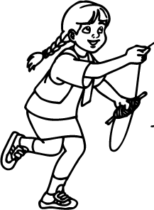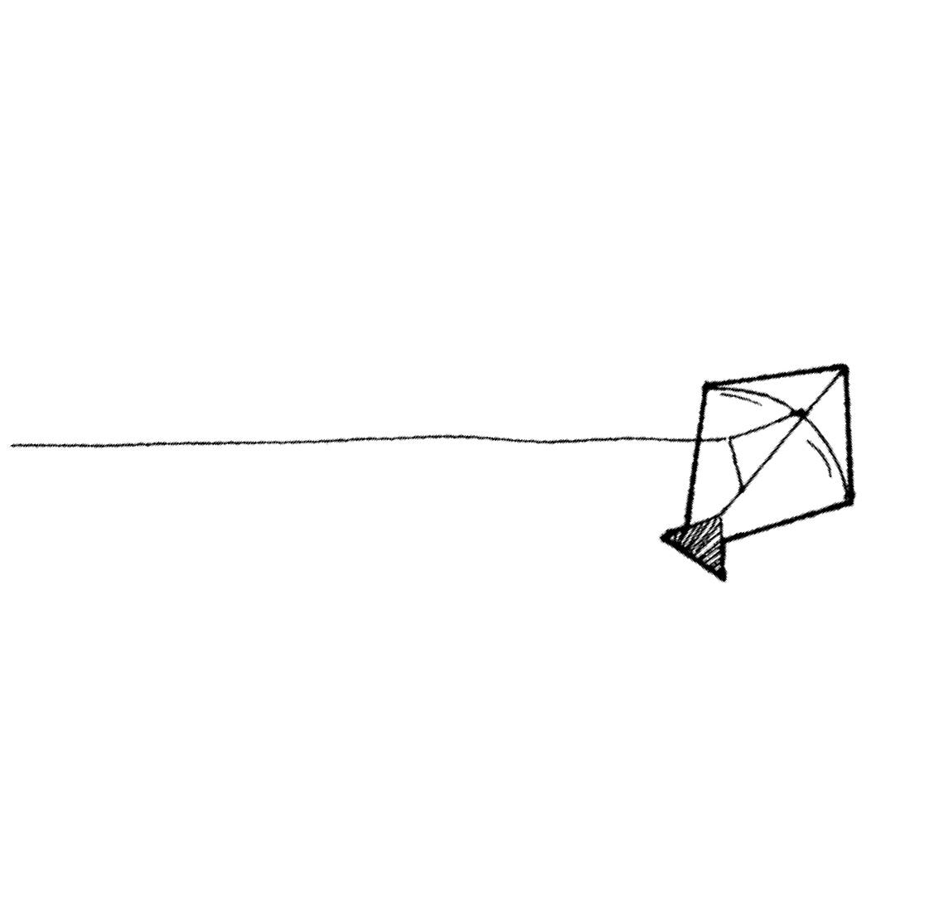

**N**

1. **(a) How are these landforms useful to people?**
   1. **Lakes**
   2. **Hills**
2. **State one way of caring for hills.**
3. **Why is it not safe to stay in a valley?**
4. **(a) What is a nuclear family?**
5. **State any two ways of keeping our homes clean.**
6. **Mention any one important room in a house.**
7. **(a) Give any two social services provided by your Sub County**

/division.



1. **Why does the government provide social services to people?**
2. **Give one problem faced by the government when providing social services to people.**
3. **(a) Give one role of children at home.**
4. **Give any two rights of a child.**
5. **How can children help to keep peace and security in a home?**
6. **(a) What do we call the things we make using our hands?**
7. **Draw and name any two things we can make using our hands.**

|  |  |
| --- | --- |
|  |  |
|  |  |

1. **Why do people make the above things?**
2. **(a) Write any two things needed to start a project.**

|  |  |  |
| --- | --- | --- |
| **(b)**  **(c)**  **157. (a)**  **(b)**  **(c)** | **Mention any one project that a P.3 child can start.**  **Why do people set up projects?**  **What are food crops?** | |
|  |  |
| **Mention any two food crops you know.**    2. **Give one problem farmers face.** | |
| 1. **Match the following correctly. A B**   **Culture - Treating of girls and boys equally.**  **Gender equity - The way people live and behave in a society. Taboo - Type of food commonly eaten in an area.**  **Staple food - Anything forbidden in a society.**  **Culture - Gender equity - Taboo - Staple food -**   1. **The graph below shows some of the birds and animals in Entebbe**   **zoo.** | | |

|  |  |  |  |
| --- | --- | --- | --- |
| **40** | **Snakes Weaverbirds Monkeys**  **How many weaver birds are there?** | **Ostritches** | **Baboons** |
| **30** |
| **20** |
| **10** |
| **0** |
| **(a)** |
| **(b)** | **Mention any one animal shown on the graph.** | | |
| **(c)** | **Which animal is dangerous to a crop farmer?** | | |
| **(d)** | **How do people care for the above animals?** | | |
| **RELIGIOUS EDUCATION**  **160. (a) Mention any two talents God gave us.**   1. **(ii)** 2. **How can you use your talents well?**   **161. (a) Identify any two different things that God created.** | | | |



|  |  |  |  |  |
| --- | --- | --- | --- | --- |
| 1. **Name any two miracles that Jesus made.**   **162. (a) Who is a prophet?** | | | | |
| **(b) Name any one prophet in the Bible.** | | | | |
| **(c)**  **(d)**  **163. (a)**  **(b)**  **(c)**  **164. (a)** | **Give any one quality of a prophet.** | | | |
| **Which prophet saved God’s creation in an Ark?** | | | |
| **On which day did the Holy Spirit come upon the disciples?** | | | |
|  | **Why did Jesus send the Holy Spirit to the disciples?** | | |
| **State two gifts of the Holy Spirit.**    2. **Name the religious customs below.** | | | |
|  | Image result for a person praying |  |  |
|  |  |  |

1. **Name any two requests made in the Lord’s Prayer.**

|  |  |  |
| --- | --- | --- |
| **PAPER 9** | | |
| **SECTION A**   1. **Name one cardinal point of a compass.** 2. **Give one way landslides are dangerous to roads.** 3. **Why do people keep ducks in their homes?** 4. **In which way can we care for our flower gardens?** 5. **State one unsafe way of using roads.** 6. **How can you prepare yourself for a rainy day?** 7. **What is a picture?** 8. **Draw and name one object used for communication.** | | |
|  |  |  |
|  |

1. **Give any one cause of insecurity in an area.**
2. **Name one economic activity carried out on lakes and rivers.**
3. **Kapere has a dog which he loves so much. In which way can this dog be dangerous to him?**
4. **State one role of a child in a family.**
5. **Why do we stand upright when singing anthems?**
6. **Mention one cash crop grown by people.**
7. **How can broken bottles be dangerous at home?**
8. **Give one way of telling direction.**
9. **Draw a map symbol of a railway line.**
10. **State any one problem children can face when they walk alone.**
11. **Name any cultural activity.**
12. **How is a school holiday useful to a P.3 child?**
13. **In which way is a bank important to a pupil?**
14. **What is a plateau?**
15. **How can we keep peace and security at home?**
16. **Write B.O.U in full.**
17. **State one use of the sun.**
18. **How are prefects useful in a school?**
19. **Why shelter is called a basic need?**
20. **Name one food crop.**
21. **How is a television important to you?**
22. **Give one danger of wild animals.**
23. **Draw and name one means used in water transport.**
24. **How many members make up the LC1 committee?**
25. **Why do people in your sub- county work?**
26. **How is windy weather useful to us?**
27. **Write one bad behaviour among school children. RELIGIOUS EDUCATION.**
28. **Name one messenger in the Bible.**
29. **What is Lent?**
30. **How can a P.3 child show love to needy people?**
31. **Give one importance of a Bible to Christians.**
32. **In which garden did Adam and Eve live?**
33. **(a) What is environment?**

(b) How are these things important in the environment?

1. **grass**
2. **trees**
3. **soil**
4. **(a) Write the name of your sub – county/division.**
5. **Why do we need police posts in our sub – county?**
6. **Give any two social services provided in your sub –**

county.

3. **Study the pictures below and answer the questions that follow.**

|  |  |
| --- | --- |
| Description: C:\Users\RECEPTION-1\Desktop\ext family.png |  |

* 1. **Name the types of families marked Q and R.**

Q R

* 1. **State any one way a family gets its needs.**
  2. **Give any one benefit of living in a nuclear family.**

1. **(a) What are physical features?**

(b) Name any two physical features.



(d) How can farmers make use of hills?

1. **(a) Why do children need recreation activities?**
2. **Name any two recreation activities . (i)**

(ii)

1. **How can children use this item during recreation?**
2. **(a) How is a map similar to a picture?**
3. **Write any two elements of a map. (i)**

(ii)

1. 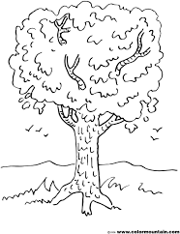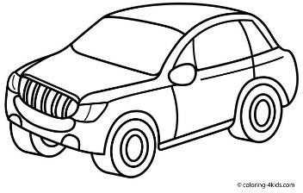**In the pictures below. What is the direction of the car from the tree?**
2. **(a) State the roles of these people in school.**
3. **Headteacher**
4. **Cooks**

(b) Give any two activities children do in their classrooms.

3. **(a) What are domestic animals?**
4. **Name any two domestic animals.**

7. **How can you care for domestic animals?**
8. **(a) Draw the following road signs.**

|  |  |
| --- | --- |
|  |  |
| **Danger ahead** | **No parking** |

1. **Which type of weather destroys roads?**
2. **How can we control accidents on roads?**
3. **Match the following people to their economic activities.**

A B

A trader sews clothes.

A tailor buys and sell goods.

A farmer makes pottery.

A potter grows crops and keeps animals.

1. **A trader**
2. **A tailor**
3. **A farmer**
4. **A potter RELIGIOUS EDUCATION.**
5. **(a) Which name in the Bible means ‘Rock’?**
6. **Why do Christians have names?**
7. **Apart from naming children, name any other traditions.**

10. **(a) Who is a leader?**
11. **State any two qualities of a good church leader.**

14. **Name one leader in the Bible.**
15. **(a) Why do children go for Sunday school services?**
16. **On which day did the apostles receive the Holy Spirit?**
17. **How is the Holy Spirit important to us?**
18. **Name one gift of the Holy Spirit.**
19. **(a) Name any two sources of light God created.**

22. **Why do people created by God pray to Him?**
23. **Mention any one place where people can pray from.**

(ii) (a) How was Mary related to Jesus?

1. **State any two miracles performed by Jesus. (i)**

(ii)

1. **Why did Jesus perform miracles?**

|  |
| --- |
| **PAPER 10** |
| **SECTION A : 40 MARKS**   1. **State one means of water transport.** 2. **Give one role a father in a home.** 3. **Why is farming important in our community?** 4. **How can we care for our compound?** 5. **Draw a map symbol for a hill in the space below.** 6. **What is a plateau?** 7. **Why do we need a market in our community?** 8. **How are recreation centres important in our community?** 9. **Give one example of a religious leader.** 10. **Name the language spoken by the Bagisu.** 11. **Why do we need police posts in our community?** |

|  |  |
| --- | --- |
|  |  |
| **176.** | **Why do people keep cats in their homes?** |
| **177.** | **Name the element of weather that helps in winnowing.** |
| **178.** | **In which one way is a map different from a picture?** |
|  |  |
| **179.** | **Give one importance of a school as a social service.** |
| **180.** | **Why is a radio important at home?** |
| **181.** | **State one cause of conflicts between a school and its neighbourhoo** |
| **182.** | **Why should a school have a signpost?** |
| **183.** | **Name the source of the raw material for making** |
| **this**  **Item**   1. **How is technology useful to you?** 2. **Why is it not good to live in valleys?** | |

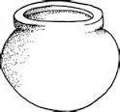

1. **What term is given to mean the keeping of resources for future use?**
2. **Mention one dangerous thing found on roads.**
3. **Give one way people spend their money wisely?**
4. **How did people of long ago tell direction without using a compass?**
5. **Why do farmers water their crops during a dry season?**
6. **Which L.C.I member is in charge of children’s welfare?**
7. **Why do we greet?**
8. **Draw and name any one item used as bride price.**
9. **How does a school benefit from a community?**
10. **Give one example of a child with special needs.**
11. **Why are children given names?**
12. **Mention any one economic activity carried out on most lakes of Uganda.**
13. **What do we call a group of people under one fore father?**
14. **Which basic need is provided by farmers?**

For questions 36 – 40, answer Christianity.

1. **Why did God send His son on earth?**
2. **Who was created in God’s image?**
3. **On which day do most Christians go for prayers?**
4. **Mention any one request made in the Lord’s Prayer.**
5. **Give one reason why people pray.**

SECTION B

1. **(a) Give another word to mean physical features.**

(b) Name any two physical features that are sources of water.

|  |  |  |  |  |
| --- | --- | --- | --- | --- |
| **(c) Which building material do we get from hills?**  **206. Fill in the missing words.** | | | |  |
|  | **Cash crops** | **Products** |  |
| **Cotton** |  |  |
| **Coffee** | **door mats, ropes** |  |  |
|  | **cigarettes** |  |  |
| 1. **(a) What is gender?**    1. **Mention any two gender roles for boys today.**    2. **Give one reason why people build houses.** 2. **(a) Mention any two basic resources in our environment.**  5. **Why do people save resources?**    1. **(ii)**   **(iii)** | | | |

|  |
| --- |
| 1. **Match the material to their sources correctly. Materials Source**   **Clay, papyrus - mines**  **Hides and skins - banana plantation . Banana fibres - swamps.**  **Minerals - animals.**  **Clay, papyrus - Hides and skins - Banana fibres - Minerals -**   1. **(a) Write B.O.U in full.** |
| 1. **Mention any two examples of commercial banks in our sub county.** 2. **Why do people keep their money in banks?** |
| **211. (a) Name two activities done by people in a community to get money.**     3. **State two problems people face when doing activities to get money.** |

|  |
| --- |
| **212. (a) Mention any two examples of child abuse.**     3. **Give one way child abuse can be controlled in your sub county.** 4. **Name any one group of people who abuse children.** 5. **Use the diagram below to answer the questions below.**   Y  W W   * 1. **Name the landform marked W.**   2. **Why is it dangerous to settle in physical feature marked Y?**   3. **How is physical feature marked W useful to people?**  1. **(a) In which sub county is your school found?**   **(e) What title is given to the political head of a sub county?** |



|  |  |  |
| --- | --- | --- |
| 1. **Mention any two members of the Local Council 1 Executive Committee?**   **RELIGIOUS EDUCATION**  **215. (a) Name two things God created in our environment?**       **(g) How do we care for God’s creation?**  **(iii) (iv)**  **216. (a) Name the last meal Jesus served to his disciples.** | | |
| **(f)** | | **What did Jesus use to feed the disciples?** |
|  | | **(i)** |
|  | | **(ii)** |
| **(g)** | | **What do you learn from the meal Jesus served his disciples?** |
| **217. (a) Give any two ways we worship God.**  **(v) (vi)**  **(e) State one importance of worshipping God.** | | |
| **(f)** | **Why is Sunday an important day to Christians?**  **_** | |

|  |  |
| --- | --- |
| 1. **How were these people bad to their brothers?**    1. **Cain :**    2. **Jacob :**    3. **How can you show love to your brother or sister?** 2. **Give the name of the following;**    1. **The name of the Promised Land.** | |
| **(b)**  **(c)**  **(d)** | **The place where Jesus performed the first miracle.** |
| **The town where Jesus was born.** |
| **The place where Jesus grew up.** |
|  |

|  |
| --- |
| **PAPER 11** |
| **SECTION A : 40 MARKS.**   1. Name **one** school symbol found on your uniform. 2. State **one** use of trees in our environment. 3. How can a P.3 pupil keep the class clean? 4. Write **one** activity done by farmers in the dry season. 5. How do children help to keep peace and security at home? 6. Name **one** animal used for transport. 7. Give one example of fuel. 8. What is communication? 9. How is this item useful to people? 10. Name **one** place which uses an ambulance for transport. 11. Why do we need police offices in our community? 12. How do children show respect to elders? |



1. Give one danger of wild animals.
2. Which item in a school is used to change school activity?
3. In which way is a zebra crossing important to a school pupil?
4. State one cause of insecurity in schools.
5. Draw and name the item used to pay bride price.
6. How are rivers useful to us?
7. State **one** danger of child abuse.
8. How can you help orphans in our community?
9. State any **one** right of children.
10. How is farming important to people?
11. Which child abuse is being carried out?
12. Give **one** reason why children eat food.



1. Write **one** use of banks to people.
2. How are floods harmful in an area?
3. Give **one** crop grown in swamps.
4. How is a school holiday important to a P.3 child?
5. Mention **one** basic need of people.
6. Why do people start projects?
7. What does this road sign show?
8. Give **one** element of a good map.
9. How do we make use of banana fibres?
10. Write one item used to keep security?
11. A is a group of people speaking the same language.

RELIGIOUS EDUCATION

1. What should you do after sinning?

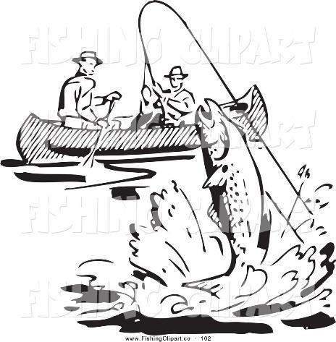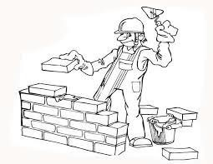

1. How is a Bible useful to a Christian?
2. Give **one** way of communicating to God.
3. In which place did Adam and Eve live?
4. State **one** reason why Jesus gave us the Holy Spirit.

SECTION B

1. **Study the diagrams below and answer the questions that follow**;
   1. Name the economic activities shown in A and B.
2. A
3. B
   1. Which materials are used to build in picture B?
   2. Why do people carry out activity A?
4. (a) In which sub – county or town council is your school found?
5. Why do people need these social services?

(i) Transport

(i) Banking

1. State **one** cause of road accidents in your sub – county.
2. (a) What are cash crops?

(b) Name any **two** cash crops grown in your area.

(d) How can you care for crops?

1. (a) Name the place where religious leaders work.
2. How are religious leaders useful to us?
3. State **two** qualities of a good leader. (i)

(ii)

1. (a) Draw and name any **two** crafts made from palm leaves.

|  |  |
| --- | --- |
|  |  |
|  |  |

1. Why do people make the above crafts?
2. Name **one** place where people can get clay.
3. (a) How does a father care for the family?
4. Name **one** room found in a house.
5. Which member of a family breast feeds a baby?
6. **Match the following resources to their uses.** Resources uses

Soil buying needs

Money growing crops

Fuel source of food

Plants running machines

* 1. Soil
  2. Money
  3. Fuel
  4. Plants

1. (a) What is a map?
2. Draw a ball in the West of this compass.

N

1. Write any **two** people who use a compass in their work.

4. **Below is a weather chart for a week.**

|  |  |  |
| --- | --- | --- |
|  | Morning | Afternoon |
| Monday |  |  |
| Tuesday |  |  |
| Wednesday |  |  |
| Thursday |  |  |
| Friday |  |  |

* 1. What was the weather on Monday?
  2. Which day was sunny both in the morning and the afternoon?
  3. For how many times did it rain in this week?
  4. Which day did not receive any rain?

1. (a) Why do people wear cultural dresses?
2. Apart from dressing, give any other **two** cultural practices. (i)

(ii)

1. Write any **one** group of people who teach us our culture.

RELIGIOUS EDUCATION

1. (a) Why is Sunday an important day for Christians?
2. Name the Christian holiday celebrated in December.
3. State **two** ways of worshipping God.

6. (a) How did Jesus show us friendship?
7. Draw and name the Christian symbol on which Jesus was crucified.
8. Who were the earthly parents of Jesus?

(i) (ii)

1. (a) What do you do when you do something bad to your friend?

(b) State **two** ways of caring for others.



(e) Name **one** gift you can give to your friend.

1. **Complete the table below correctly**

|  |  |
| --- | --- |
|  | led Israelites out of Egypt |
| John the Baptist |  |
| Noah |  |
|  | Doubted Jesus’ resurrection |

1. (a) Where can people pray from?
2. Why do people pray to God?
3. State any **one** miracle done in churches today.

|  |
| --- |
| **PAPER 12** |
| **SECTION A : 40 MARKS**   1. **What name is given to the four major points of a compass?** 2. **In which sub county is your school located?** 3. **Give one role of barbers in our community.** 4. **Write one activity done by people to provide building materials.** 5. **Write LC in full.** 6. **What is a map?** 7. **How can a P.3 pupil use a road safely?** 8. **State one way people care for domestic birds.** 9. **How can we help our parents at home?** 10. **Mention one activity done at school.** |

1. **Draw and name one item used to manage sunny weather.**
2. **What is a clan?**
3. **How can you care for hills in our sub county?**
4. **Why is it good to live near a health centre?**
5. **Why do P.3 children need holiday?**
6. **Give one way of telling direction of places.**
7. **Give one way of finding the direction of places.**
8. **What do we call a person who grows crops and keeps animals?**
9. **State one danger caused b y too much rain.**
10. **How do children help to keep security at home?**
11. **Why do we need rivers and lakes in our division?**
12. **Mention one common custom in your sub county.**
13. **Give one way a community is helpful to a school.**
14. **Why do people grow crops?**
15. **Name one animal used for transport?**
16. **Show West (W) direction on the compass rose below.**

**N**

1. **Name one tribe found in your sub county.**
2. **How can you make use of banana fibres in our environment?**
3. **How do dogs help to keep security?**
4. **How can we show respect to the National anthem when it being sung?**
5. **Name one source of water.**
6. **Mention one class rule.**
7. **Give one example of a landform.**
8. **Give one way in which shopkeepers are important in a community.**
9. **How can we care for social service centres?**

For questions 36 – 40, answer Christianity.

1. **Name one example of traditional custom.**
2. **How can we care for God’s creation?**
3. **Why do Christians fast?**
4. **Name one item used during Baptism.**
5. **Where did Jesus change water into wine?**

SECTION B

1. **(a) What are food crops?**
2. **Mention any two examples of food crops.**
3. **How can we care for our crops?**
4. **(a) State one role of each of these people in a family.**
   1. **Mother**
   2. **Father**
5. **Mention two basic needs of a family.**
6. **(a) What is a transport?**

(b) Name the colours of the traffic light below.

X

Orange

Y

1. **X**
2. **Y**

(c) How is a zebra crossing important to a pedestrian?

1. **(a) Which activities do farmers carry out in these seasons?**
   1. **Dry season**
   2. **Wet season**
2. **Mention the clouds that give people rain.**
3. **Why do people wear light clothes on a hot day?**
4. **(a) Who is a leader?**
5. **Name one type of leader.**
6. **State two qualities of a good leader.**

9. **Match the following correctly.**

A B

carpenters keep law and order

shopkeepers treat sick animals.

police officers sell in shops

veterinary doctor make furniture

1. **carpenters**
2. **shopkeepers**
3. **police officers**
4. **veterinary doctor**
5. **(a) What are domestic animals?**
6. **Mention two domestic animals used for transport.**
   1. **(ii)**
7. **State one danger of domestic animals.**
8. **Study the diagram below and answer the following questions.**



D

B

A C

1. **Name the physical features marked with letters.**
   1. **A (ii) C**
2. **State one danger of staying in C.**
3. **Give one human activity carried out on B.**
4. **(a) Give two examples of basic resources.**
5. **Why do we save money?**
6. **(a) What is a home?**
7. **Where do these animals live?**
   1. **Fish**
   2. **Monkey**
8. **Why should a home have a fence?**

|  |  |
| --- | --- |
| **RELIGIOUS EDUCATION**  **270. (a) On which day did the Holy Spirit come on the disciples?** | |
| **(h)**  **(i)**  **271. (a)**  **(h)** | **Name two gifts of the Holy Spirit.**  **(i) (ii) Why did Jesus give us the Holy Spirit?** |
| **Mention any two non – living things God created.**  **(i) (ii)** |
| **For how long did God take to create everything?** |
| **(i) Why was man chased from garden of Eden?**  **272. (a) Match the following correctly. A B**  **Wine The body of Jesus**  **Dove The death of Jesus**  **Cross The Holy spirit**  **Bread The blood of Jesus**   1. **Wine** 2. **Dove** 3. **Cross** 4. **Bread** | |

|  |  |  |
| --- | --- | --- |
| **273. (a) Name any two Christian customs.**       **(g) What does the name ‘Emmanuel ‘mean?** | | |
| **(h)**  **274. (a)**  **(f)** | **Mention one other Christian name.** |  |
| **Write any two ways we worship God.**    2. **Name any two places of worship in our sub county.** | |

|  |
| --- |
| **PAPER 13** |
| **SECTION ‘A’ – 40 marks**   1. What is a family? 2. Why do school children put on school uniform? 3. Mention any **one** element of weather. 4. What does this symbol mean on the road?      1. Name any **one** neighbour of our division. 2. Why do we need hospitals in our division? 3. Write **one** cardinal point you know. 4. What do we call a drawing of an object drawn as seen from sides? 5. Write any **one** project carried people in our division. 6. Why are mountains important in our division?   _   1. Draw this thing we use for sweeping compound at home.      1. Write **one** use of a hoe at home. 2. What is the main source of water? 3. What is culture? |



1. Write any **one** means of modern communication.
2. Name this activity children do at school.
3. Name any **one** material that can be used to build a permanent house.
4. Why do we need a chair in the house?
5. Which condition of weather brings rain?
6. Write any **one** way of rearing poultry.
7. What do we call living in peace and harmony with others in the community?
8. Write any **one** basic need of a family.
9. Name any **one** resource found in our sub-county.
10. Why do school children need bags?
11. Name any **one** group of people who use a map for doing their work.
12. Who heads a school?
13. Which type of transport do use when going back home?
14. Katongole is sick. Which basic need is needed for his treatment?
15. Name any **one** wild animal you know.
16. What is a resource?
17. Draw this thing found at school.

|  |  |  |
| --- | --- | --- |
| 32.  33.  34.  35.  36.  37.  38.  39.  40.  4  1 | Nam Wh Wh Nam Ho Me Wr Wh Nam  (a) | e any **one** member of an extended family. at is the role of traffic officer on the road?  at title is given to the person who heads a family? e **one** physical feature found in our sub-county.  w useful is a key on a map?  ntion **one** food we get from lakes. ite BOU in full.  ich domestic animal promotes security at home? e any **one** thing needed before starting a project.  **SECTION B**  What is a map?    _ |
|  | (b)  ` | Write two qualities of a good map |
|  | (c) | On the compass below, name the cardinal point North. |
|  |  |  |

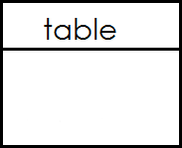

|  |  |  |
| --- | --- | --- |
| 4  2 | (a) | Write any **two** domestic animals found at home. |
|  | (b) | Give **two** reasons why people keep animals at home. |
| 4  3 | (a) | Draw these important places. |
|  | (b) | Write any **two** things found at school. |
| 4  4 | (a) | What is transport? |
|  | (b) | Write **two** types of transport in our sub-county. |
|  | (c) | Why do most people in our division use road transport? |

|  |  |  |
| --- | --- | --- |
| 4  5 | (a) | What do we call the process of sending and receiving massages from one place to another? |
|  | (b) | Name any **two** services provided to people in our sub-county. |
|  | (c) | Name this traditional means of communication |
| 4 | (a) | Why do we need leaders at school? |
| 6 |  |  |
|  | (b) | Give two examples of leaders found at school. |
|  | (c) | Write any one rule found in your classroom. |
| 4 | (a) | What are basic needs? |
| 7 |  |  |
|  | (b) | Name these basic needs of a family. |

|  |  |  |
| --- | --- | --- |
| 4  8 | (a) | What are physical features? |
|  | (b) | Mention three examples of physical features. |
| 4  9 | (a) | What is culture? |
|  | (b) | Give any one cultural activity done in our community. |
|  | (c) | Name any two cultural foods people eat in our sub-county. |
| 5  0 | (a) | What do we call keeping something or someone safe? |
|  | (b) | Draw these things used for keeping peace and security. |
|  | (c) | Why do some people keep dogs in their homes? |

|  |  |  |
| --- | --- | --- |
| 5  1 |  | Match the following correctly |
| 5 | (a) | Which fish is caught from swamps? |
| 2 |  |  |
|  | (b) | Mention **three** crops grown in swampy areas. |
| 5 | (a) | Who is a child? |
| 3 |  |  |
|  | (b) | Give **two** rights of children. |
|  |  | (i) |

(c)

(a)

5

4

(ii) Name the LC1 executive committee member responsible for the welfare of children.

What is weather?

1. Give **three** types of weather.

5 (a)

5 i)

ii)

iii)

iv)

Name the following symbols used on a map.

 :

:

 :

:

|  |
| --- |
| **PAPER 14** |
| **SECTION ‘A’ – 40 marks**   1. What name is given to a group of people living and working together? 2. Mention **one** cardinal point on a compass. 3. Write LC in full. 4. What is a plateau? 5. Which is the largest lake in Uganda? 6. Give the main natural source of water in your area. 7. What title is given to a head of a school? 8. In the space provided below draw a map symbol for a swamp. 9. Mention any **one** language spoken by people in your community. 10. How many colours has the Uganda flag? 11. Give the role of a mother at home. 12. Mention the quickest type of transport. |

1. Which traffic light tells drivers to stop?
2. Mention the commonest type of fish caught in Uganda.
3. State **one** important place in your community.
4. Give **one** common accident at home.
5. Mention **one** item found in the first aid box.
6. What name is given to a place where people keep their money safely?
7. In which district is your school found?
8. Which animal provides security at home apart from a dog?
9. What name is given to a low land between two hills?
10. Which clouds give us rain?
11. In which direction does the sun rise?
12. Give **one** example of a cash crop in your area?
13. How useful is a kitchen at school?
14. In which season do farmers water their crops?
15. Name **one** tool used to keep peace in the country.
16. Mention any **one** need of a school.
17. What is a map?
18. Mention any **one** place where social services are provided from.
19. Name **one** domestic animal which gives people milk.
20. Mention **one** material used to build a permanent house.
21. Give **one** symbol of a school.
22. Why do school children wear uniforms?

_ For questions 35-39, answer either Christianity or Islam but not both on the same number.

1. ***Either***: In how many days did God create the world?

***Or:*** In how many days did Allah create the world?

1. ***Either:***

Mention the angel who announced the good news about the birth of Jesus Christ to Mary.

***Or:*** Name the last prophet in Islam.

1. ***Either:***

Mention the first book in the Bible.

***Or:*** Name the first Surat in the Quran.

1. ***Either:***

Name the mountain where Moses received the Ten Commandments from God.

***Or:***

Who led the ban Israel out of Misri?

1. ***Either:***

Who is your neighbor according to Christianity?

***Or:*** Who is your neighbor according to Islam?

SECTION ‘B’

1. What are basic needs?
2. Mention **three** examples of basic needs in your community.
3. What is fishing?
4. Give **one** traditional method of preserving fish.
5. Mention **two** lakes you know.
6. What is communication?

b) Give **three** means of communication in your area.

(i) (ii)

(iii)

1. Match correctly.

Optician examines and treats eyes

Dentist operates sick people

Surgeon treats our eyes

Oculist examines and treats our teeth

1. Mention **two** elements of weather.
   1. (ii)
2. Give **one** condition of weather which allows people to wear sweaters.
3. Name **one** weather instrument you know.
4. Name **two** ethnic groups in your community.
   1. (ii)

b) Mention **two** tribes in your community.

2. What are physical features?

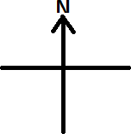

1. Give **three** examples of physical features.
   1. (ii)

(iii)

1. Match correctly.

Baganda Runyankole

Bagisu Rutooro

Batooro Luganda

Banyankole Lumasaba

1. Name the following map symbols.
2. In which direction does a compass needle rest?
3. Mention the cardinal points of a compass.

***For questions 50 – 54, answer Either Christianity or Islam BUT NOT both in a number***

1. ***Either:***
2. Mention **two** apostles of Jesus Christ.

(ii) (ii)

1. Which apostle of Jesus Christ did the following;
   1. Denied him three times
   2. Betrayed him

***Or:***

(a) Name the prophets who received the following books. Quran Injir Tauret Zabur

1. ***Either:***
2. Which prayer did Jesus Christ teach his disciples?
3. Mention requests Christians ask for in the above prayer 51(a).
4. Name the helper Jesus Christ promised to send to his apostles.

***Or:***

1. What are impurities?
2. Give **three** impurities in Islam.
   1. (iii)
3. ***Either:***
4. What is a prayer?
5. Give **two** reasons why Christians pray to God.
6. Mention **one** type of prayer in Christianity.

***Or:*** What is prayer?

* 1. Give **two** reasons why Muslims pray to Allah.
  2. Mention **one** type of prayer said by Muslims in the morning.

1. ***Either:***
2. What is a gospel?

_

1. Mention **two** gospel books in the bible.
   1. (ii)
2. Name **one** gospel writer in the bible.

***Or:*** How many days do Muslims fast?

1. Mention **three** pillars of Islam.
   1. (ii)

(iii)

1. **For both**
2. Who built the ark?
3. Mention **two** sons of Noah.

(i) _ (ii)

1. Name the mountain where Noah`s ark rested.